Project Report
On
“Exam Management System”

Submitted By,
Vishwesh A. Tak
Shubham B. Rajput
Pavan K. Patil
Uday S. Patil

Under the Guidance of
Mrs.S.R.Landge



Department of Information Technology
Government Polytechnic, Jalgaon
Maharashtra State Board of Technical Education

Department of Information Technology
Government Polytechnic, Jalgaon
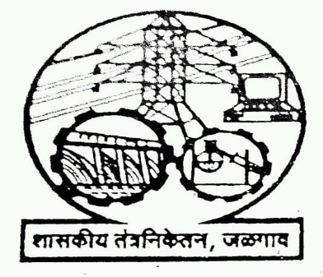

Certificate

This is to certify that the group of following students of third year has successfully completed their project on “Exam Management System” for the partial fulfillment of the diploma in Information Technology awarded by Maharashtra State Board of Technical Education, Mumbai during academic year 2018-19.

Submitted By,
Vishwesh A. Tak
Shubham B. Rajput
Pavan K. Patil
Uday S. Patil

Mrs. S. R. Landge Dr. S. D. Patil
(Project Guide) (Head of Department)

Dr. M. V. Ingale
(Principal) External Examiner
ACKNOWLEDGEMENT

I am feeling too glad to submit my project on “Exam Management System” to the Institute of Government Polytechnic Jalgaon. I also pay my thanks to the director of our institute & other teaching & non-teaching staff for all their precious guidance during the completion of this project.

As a partial fulfilment of Diploma course in the Information Technology Engineering under the Maharashtra State Board of Technical Education, Mumbai during the academic year 2018-19.

We take this opportunity to thank our Principal Mr. and Head of Department Dr.S.D.Patil for providing all facilities, which were indispensable in the completion of this seminar. We would like to thank Mrs.S.R.Landge for providing to be a great help by giving us guidance through their vast experience and intellectual skills. We are also thankful all the staff members of the Information Technology Department.

We would also like to thank the college for providing the required magazines, books and access to the Internet for collecting information related to project. I express my sincere thanks to my friends and parents for their moral support without which this project would not have exist or completed
Vishwesh A. Tak
Shubham B. Rajput
Pavan K. Patil
Uday S. Patil

Abstract

In Real Time System Exam Scheduling is very difficult task for Organizer. There is many difficulties and complications in allocating Exam Center, Exam Hall, Exam Date and Time. To solve this problem and exam planning and center allocation should be easy, we make this project.

This project develops software for college, School and Organization which conducts board exam for Students like at the time of gathering, technical events. Exams are conducted at various departments at centers on different dates at particular time. Only few members are allowed to write the exam at particular time on a date at any center and exam hall like exam hall has limited students seating arrangement (example: in DH4 hall only 60 students can seat).

Main task of our project is that reduce the work load of exam conductor to allocate Exam center, Exam hall, Exam Date and Time, and creating Exam hall tickets with exam related information like students Exam Center, Hall Number, Exam date and Time etc. After creating hall tickets send it to each student’s mail id individually, this task is very complex and time consuming for exam scheduler and required more man power to execute this. So, to make it easy and fast we develop smart and effective exam Scheduler software.

INDEX

Sr. No. Topic

1 CHAPTER 1. Introduction

2 CHAPTER 2. Requirement Analysis
2.1 Requirement Specification
2.1.1 Hardware System Configuration (min):-
2.1.2 Software System Configuration: -
2.2 About Software’s and Requirement
2.3 Requirement Validation
2.4 Module
2.5 Project Estimation
2.5.1 Effort Equation
2.5.2 Schedule Equation
3 CHAPTER 3. System Analysis
3.1 Constraints of a System
3.2 Properties of a System
3.3 Analysis Model
3.3.1 Behavioral Modeling
3.3.2 Functional Modeling
4 CHAPTER 4. System Design
4.1 Definition
4.2 Data Design
4.2.1 Admin Login
4.2.2 Teacher Login
4.3 Architecture Design
4.3.1 Presentation Layer
4.3.2 Application Layer
4.3.3 Data Layer
4.3.4 Two-Tier Architecture

5 CHAPTER 5. Implementation Detail
5.1 Login Module
5.2 Shedule for seat number
5.3 Home Page
5.4 Student Registration Form
5.4 Add Supervisor
5.5 Adding exam room
5.6 Allocate Exam Room
5.7 Selecting Department And Semister
5.8 schedule exam from seat number to seat number in room

6 CHAPTER 6. Testing
6.1 Definition
6.2 Testing Methodolgies
6.2.1 Black box testing
6.2.2 White box testing
6.2.3 Gray box testing
6.3 Type of testing

7 CHAPTER 7. Application and Future Scope

- CONCLUSION

- REFERENCE

CHAPTER 1
INTRODUCTION

INTRODUCTION

Exam Management System is a software developed for the students who give exams in colleges. It facilitates to access the examination information of a particular students in a particular class. The information is sorted by the operators, which will be provided by the teacher for a particular class. This system will also help in evaluating examination eligibility criteria of a student.
Exam Management is a term to manage the exam system in terms of student registered for exam, Student can view their Timetable for exam, and Student can view their seating arrangement with the help of our Exam Management System project.

Highlight
- Cut your time – by giving information about exam system when compared to the manual process this saves time of student.

- Reduce the work load of conductor.

- Time efficiency.

CHAPTER II

REQUIREMENT ANALYSIS

2.1 Requirement Analysis
Software requirement engineering is a process of discovery, refinement, modeling and specification.
“Requirement analysis is a software engineering task that bridges gap between system-level requirements engineering and software design.”
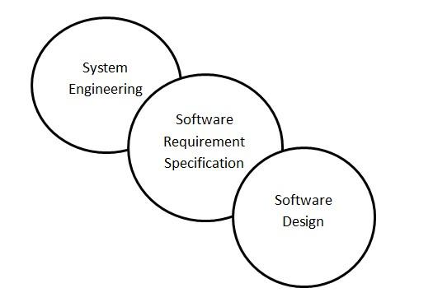
Figure 2.1: Analyses a bridge between system engineering and software design

2.2 Requirement Specification

2.2.1 Hardware System Configuration (min):-

2.2.2 Software System Configuration: -

2.3 About software’s and languages:

- MYSQL 5.0:

- Features:
- Cross-platform support
- Updatable views
- Information schema
- Multiple storage engines, allowing one to choose the one that is most effective for each table in the application.

2.4 Requirement validation
Requirements validation is an iterative process which takes place throughout the lifecycle of the project. During elicitation, analysis and specification you should constantly be questioning and clarifying the data given to you in order to check its validity. This will ensure that the SRS that you produce is complete, consistent and ready for the formal validation process.
During the formal requirements validation process you are aiming to ensure that the SRS is complete, consistent, modifiable and traceable. You are also testing to makes sure that the requirements statements themselves are complete, correct, feasible, necessary, prioritized, unambiguous and verifiable. This may seem like a lofty task but it is essential to pick up any gaps or errors at this stage in order to minimize defects later.
The costs associated with rectifying defects later in the process are exorbitant. Ironing out as much possible at this stage should be your priority. There are many techniques available to help you with the process. Most the techniques involve all the stakeholder representatives reading the requirements; carrying out problem analysis; meeting; discussing, resolving issues and collaboration that will result in consensus and the requirements baseline being set.
2.5 Module:
- External & Internal Invigilator Duty Allotment: Duty will be allocated to the teachers automatically in the system.
- Examination Invigilator Scheme/Hall Allocation To Candidates: According to the seating arrangement hall will be allocated to the examiners.
- Seating Arrangement: The system design process is not a step-by-step adherence of clear procedures and guidelines. Though, certain clear procedures and guidelines have emerged in recent days. But still much of design work depends on knowledge and experience of the designer. When designer starts working on system design, he will face different type of problems. Many of these will be due to constraints imposed by the user or limitations of the hardware and software available in the market. Sometimes, it is difficult to enumerate the complexity of the problems and solutions thereof since the variety of likely problems is so great and no solutions are exactly similar. However, following considerations should be kept in mind during the system designing phase:
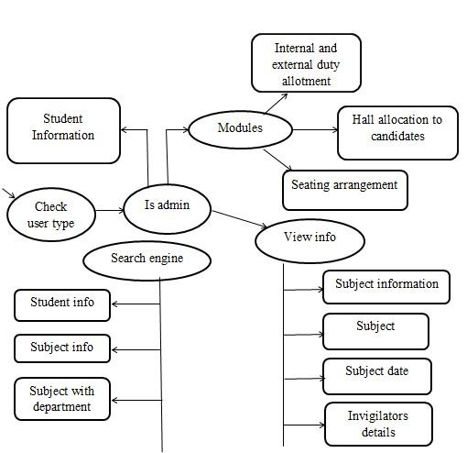
Figure 2.5: Module

2.6 Project Estimation:

2.6.1 Effort Equation
The COCOMO model makes its estimates of required effort (measured in PersonMonths -- PM) based primarily on your estimate of the software project's size (as measured in thousands of SLOC, KSLOC)):

Effort = 3 * EAF * (KSLOC)^{E}

Where,
EAF: Is the Effort Adjustment Factor derived from the Cost Drivers E: Is an exponent derived from the five Scale Drivers

As an example, a project with all Nominal Cost Drivers and Scale Drivers would have an EAF of 1.00 and exponent, E, of 1.0997. Assuming that the project is projected to consist of 8,000 source lines of code, COCOMO estimates that 28.9 Person-Months of effort is required to complete it:

Effort = 3 * (1.0) * (8)^{1.0997} = 29.52 Person-Months

2.6.2 Schedule Equation:
The COCOMO schedule equation predicts the number of months required to complete your software project. The duration of a project is based on the effort predicted by the effort equation:
Duration = 3 * (Effort)^{SE}
Where
Effort: Is the effort from the COCOMO II effort equation
SE: Is the schedule equation exponent derived from the five Scale Drivers
Continuing the example, and substituting the exponent of 0.3179 that is calculated from the scale drivers, yields an estimate of just over a year, and an average staffing of between 3 and 4 people:

Duration = 3 * (29.52)^{0.3179}
Duration = 3 * 2.9332561416
Duration = 8.8 Months
Average staffing = (29.52 Person-Months) / (8.8 Months) = 3.3 people

CHAPTER III

SYSTEM ANALYSIS

It is a process of collecting and interpreting facts, identifying the problems, and decomposition of a system into its components. System analysis is conducted for the purpose of studying a system or its parts in order to identify its objectives. It is a problem solving technique that improves the system and ensures that all the components of the system work efficiently to accomplish their purpose. Analysis specifies what the system should do.

Existing system
Existing system is very slow and inefficient. There is a lot of manual work involved in current system and mistake in one detail can lead to errors. No proper collection of requirements leads a huge problem for this system. This system is to enhance manual work and also more energy is wasted to allocate the seating arrangement.

Disadvantages of existing system
- Current system is manual so all the records are maintained manually. So the seating arrangement of students cannot be determined if updating is not done.
- Time Consuming
- Less Efficient
- More manual Work Required
- Less Accurate
- Not User Friendly

3.1 Constraints of a system:

A system must have three basic constraints −
- A system must have some structure and behavior which is designed to achieve a predefined objective.
- Interconnectivity and interdependence must exist among the system components.
- The objectives of the organization have a higher priority than the objectives of its subsystem.
- For example, traffic management system, payroll system, automatic library system, human resources information system.

3.2 Properties of a system:

A system has the following properties –

1: Organization:

Organization implies structure and order. It is the arrangement of components that helps to achieve predetermined objectives.
2: Interaction:

It is defined by the manner in which the components operate with each other. For example, in an organization, purchasing department must interact with production department and payroll with personnel department.

3: Interdependence:

Interdependence means how the components of a system depend on one another. For proper functioning, the components are coordinated and linked together according to a specified plan. The output of one subsystem is the required by other subsystem as input.
4: Integration:

Integration is concerned with how a system components are connected together. It means that the parts of the system work together within the system even if each part performs a unique function.
5: Central Objective:

The objective of system must be central. It may be real or stated. It is not uncommon for an organization to state an objective and operate to achieve another. The users must know the main objective of a computer application early in the analysis for a successful design and conversion.

3.4 Analysis model:

3.4.1 Behavioral modeling

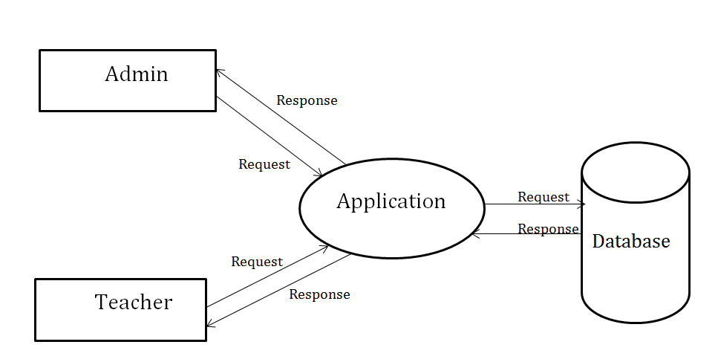

Figure 3.4.1: Context free diagram for exam system Management.

3.4.2 Functional modeling

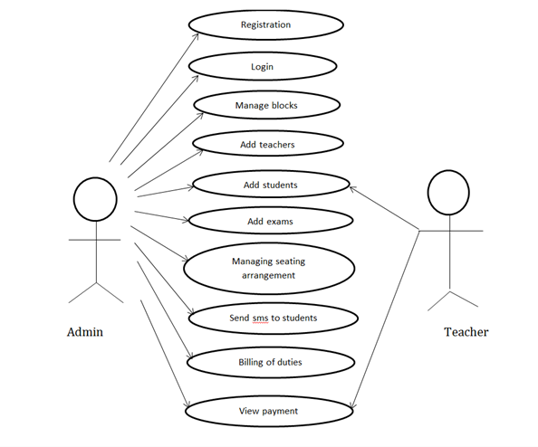
Figure 3.4.2: Use-case diagram
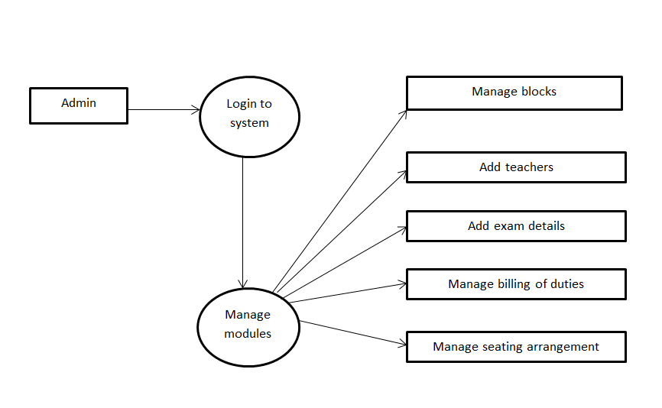

Figure 3.4.3: Data flow diagram

CHAPTER IV

SYSTEM DESIGN

4.1 Definition:
The system design phase converts the general requirements defined in the analysis phase into detailed specification for the new system. Until now, the analyst has been using the general knowledge about the specific operations, and an ability to get information from the people. Based on the user requirements, the new system must be designed. This is the system design phase, which is the most crucial phase in the development of the system.
Developing a real time application for any system utilities involves two processes namely,
- The first process is to design the system and implement it.
- The second process is to construct the executable code.
Design refers to the process of translating performance specifications recommended in analysis phase into design specifications.
The process of design involves –
- Input Design
- Output Design
- Database Design

Input Design
Input design is the process of converting user-oriented formats to computer-based formats. The input design in made user-friendly, in such a way that they could enter data online through a keyboard. A formatted form is a preprinted form that requests the user to enter data in appropriate locations. The name and number of teachers are given as input and also the student seat numbers are extracted from the excel sheet provided by university.

Output Design
The normal procedure in developing a system is to design the output in detail first and then move back to the input. The output will be in the form of views and reports. The output from the system is required to communicate the result of processing to the users. They are also used as the permanent copy for later verifications. Auto generation of seat numbers and supervision for teachers.

Database Design
Database is a collection of data. It is designed to serve the users quickly and efficiently. The database was designed using relational model and stored in different tables. The fields in a relational model such as primary key, foreign key and description fields.
4.2 Data design:
Table 4.2.1 Admin_Login

Field Name | Data Type | Key
Username | VARCHAR | Primary Key
Password | VARCHAR | -
Table 4.2.2 Teacher_Login

Field Name | Data Type | Key
Username | VARCHAR | Primary Key
Password | VARCHAR | -

4.3 Architecture design:
Architecture consists of One Tier, Two Tier, Three Tier and N-Tier architectures. A tier can also be referred to as a layer.
Three layers involved in the application namely Presentation Layer, Business Layer and Data Layer.

4.3.1 Presentation layer:
It is also known as Client layer. Top most layer of an application. This is the layer we see when we use software. By using this layer we can access the webpage’s. The main functionality of this layer is to communicate with Application layer. This layer passes the information which is given by the user in terms of keyboard actions, mouse clicks to the Application Layer.
For example, login page of Gmail where an end user could see text boxes and buttons to enter user id, password and to click on sign-in. In a simple words, it is to view the application.

4.3.2 Application layer:
It is also known as Business Logic Layer which is also known as logical layer. As per the g-mail login page example, once user clicks on the login button, Application layer interacts with Database layer and sends required information to the Presentation layer. It controls an application’s functionality by performing detailed processing. This layer acts as a mediator between the Presentation and the Database layer. Complete business logic will be written in this layer. In a simple words, it is to perform operations on the application.

4.3.3 Data layer:
The data is stored in this layer. Application layer communicates with Database layer to retrieve the data. It contains methods that connects the database and performs required action e.g.: insert, update, delete etc. In a simple words, it is to share and retrieve the data.

4.3.4 Two-Tier Architecture
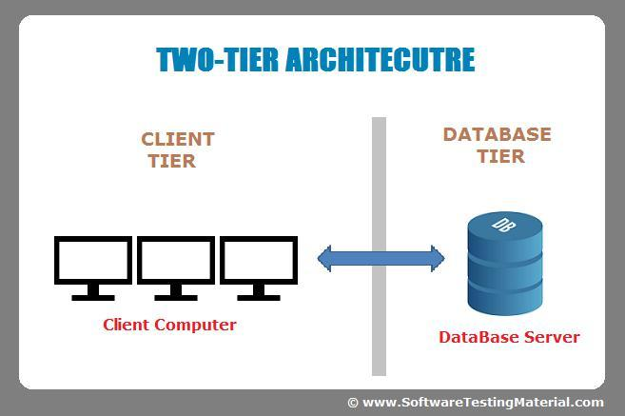

Figure 4.3.4: Two Tier Architecture

The Two-tier architecture is divided into two parts:
- Client Application (Client Tier)
- Database (Data Tier)

Client system handles both Presentation and Application layers and Server system handles Database layer. It is also known as client server application. The communication takes place between the Client and the Server. Client system sends the request to the Server system and the Server system processes the request and sends back the data to the Client System.
CHAPTER V
IMPLEMENTATION DETAIL

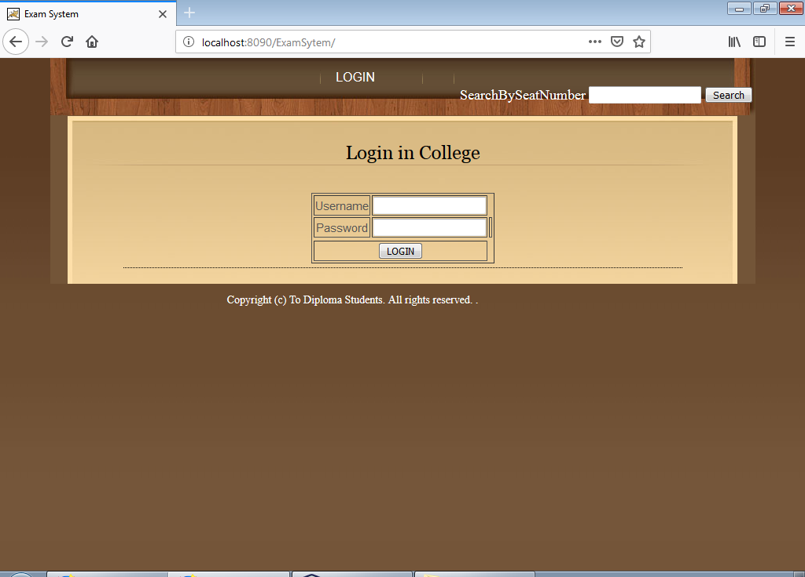

Figure 5.1: Login module
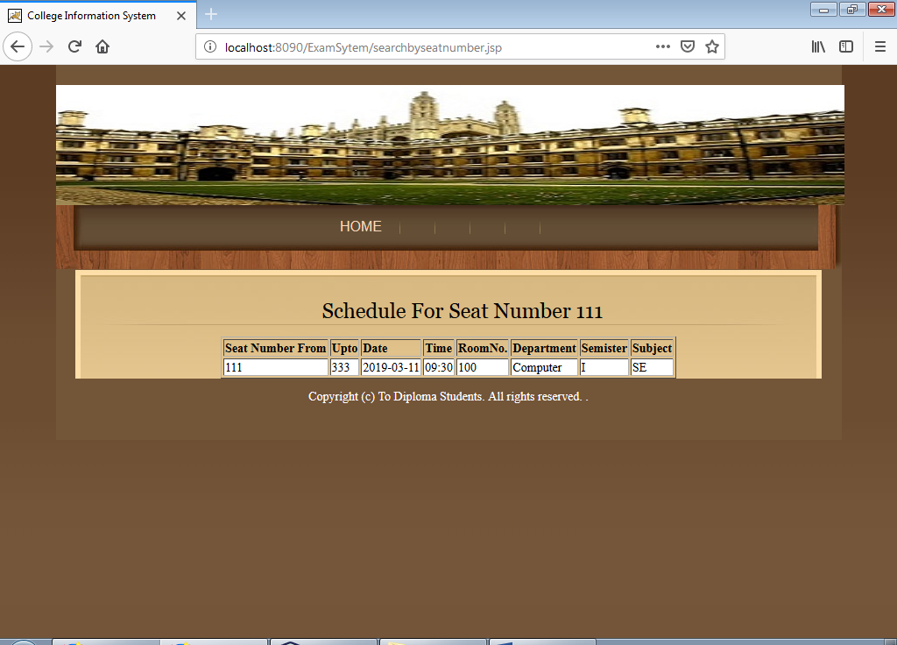

Figure 5.2:Schedule for seat number
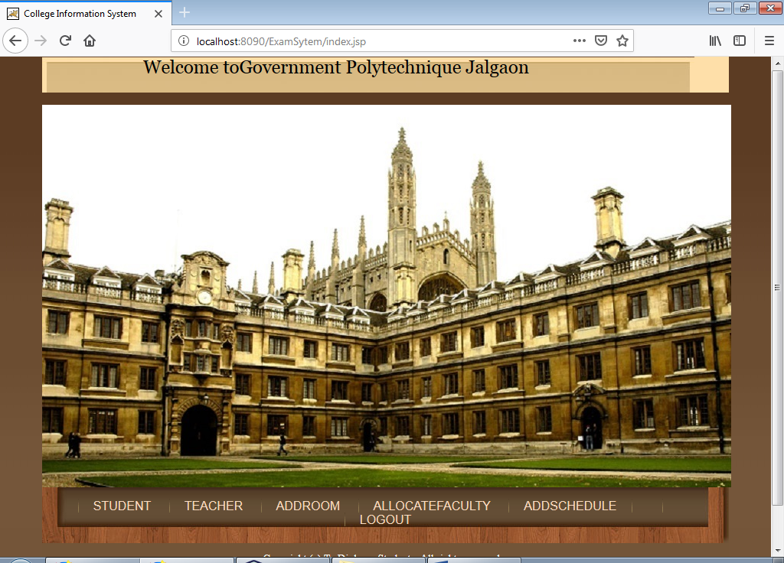

Figure 5.3: Home Page.
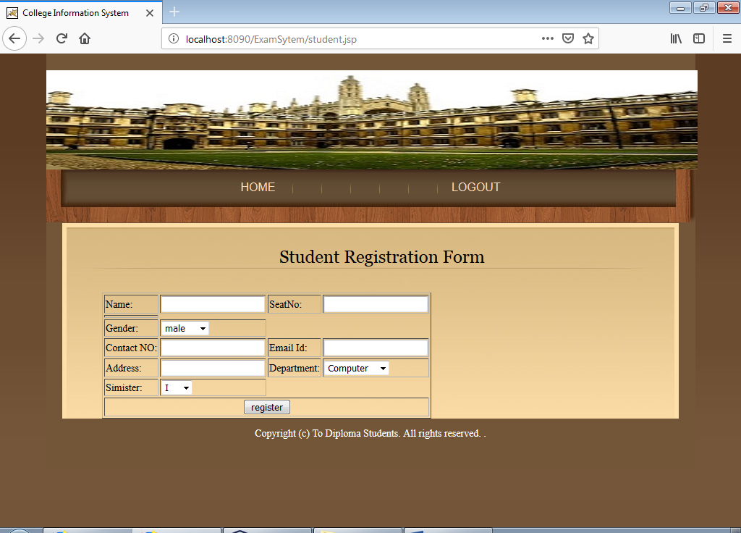
Figure 5.4: Student Registration Form
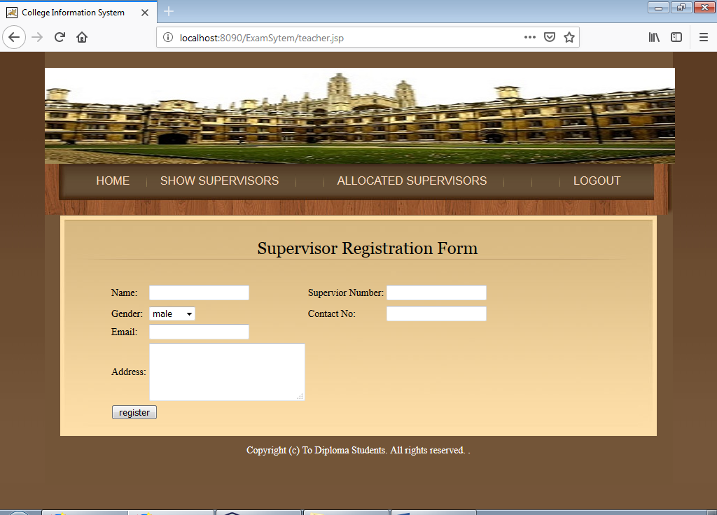
Figure 5.5:Add Supervisor.

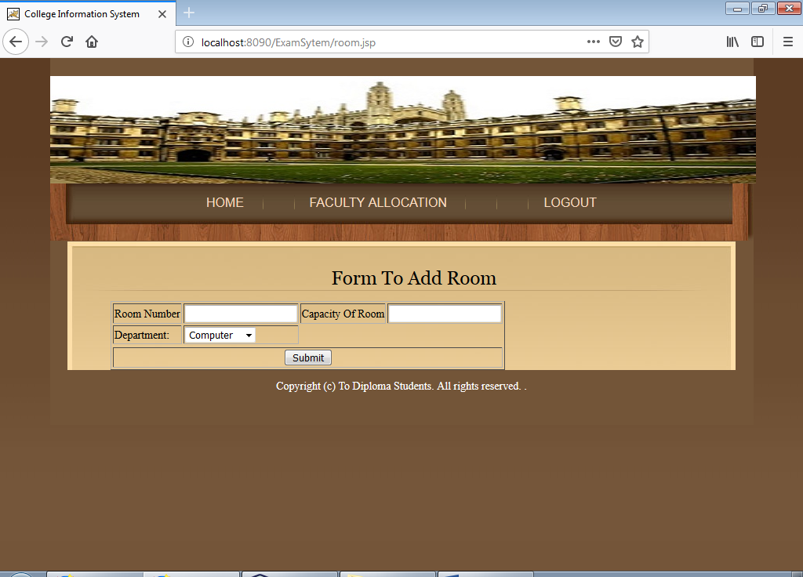
Figure 5.6 Adding exam room .
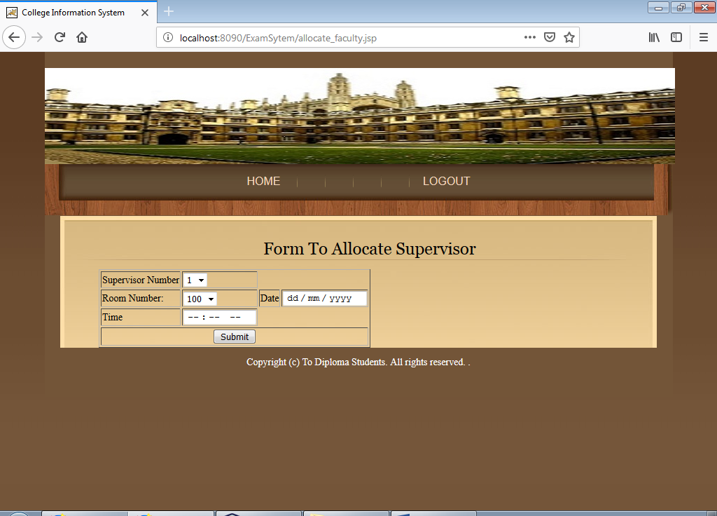
Figure 5.7 Allocate Exam Room.
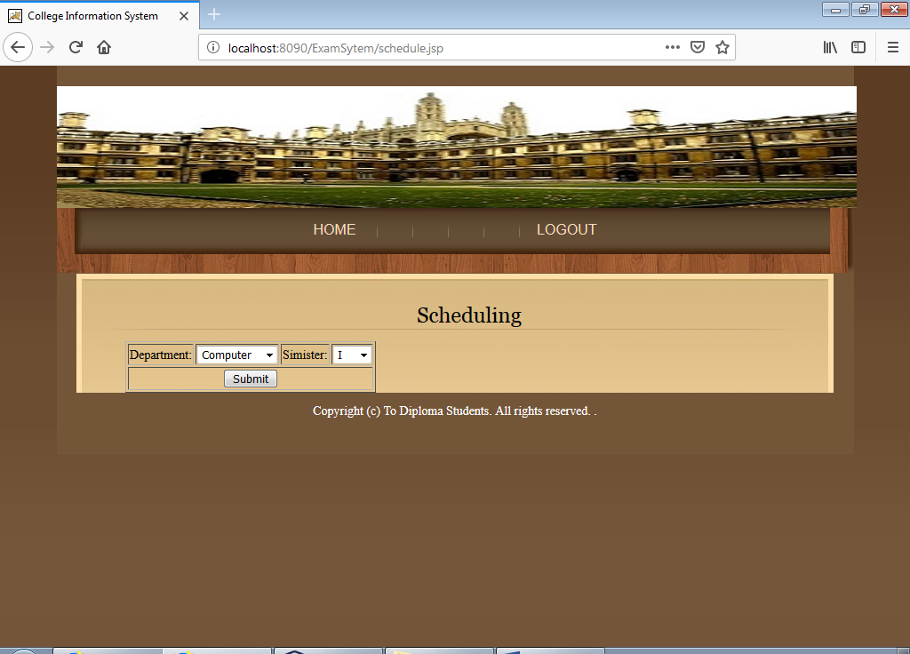

Figure 5.8 Selecting Department And Semister
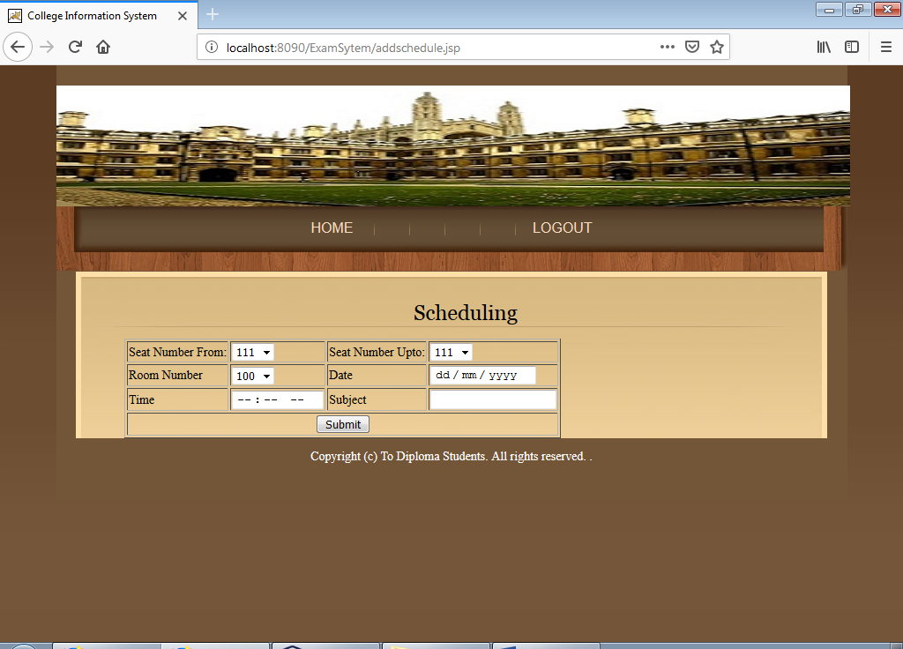
Figure 5.10 schedule exam for from seat number to to seat number students in particular room at particular date and time

CHAPTER VI
TESTING

In general, software engineers distinguish software faults from software failures. In case of a failure, the software does not do what the user expects. A fault is a programming error that may or may not actually manifest as a failure. A fault can also be described as an error in the correctness of the semantic of a computer program. A fault will become a failure if the exact computation conditions are met, one of them being that the faulty portion of computer software executes on the CPU. A fault can also turn into a failure when the software is ported to a different hardware platform or a different compiler, or when the software gets extended. Software testing is the technical investigation of the product under test to provide stakeholders with quality related information.
Software testing may be viewed as a sub-field of Software Quality Assurance but typically exists independently (and there may be no SQA areas in some companies). In SQA, software process specialists and auditors take a broader view on software and its development. They examine and change the software engineering process itself to reduce the amount of faults that end up in the code or deliver faster.
Regardless of the methods used or level of formality involved the desired result of testing is a level of confidence in the software so that the organization is confident that the software has an acceptable defect rate. What constitutes an acceptable defect rate depends on the nature of the software. An arcade video game designed to simulate flying an airplane would presumably have a much higher tolerance for defects than software used to control an actual airliner. [Type the company name] 30 Training & Placement System
A problem with software testing is that the number of defects in a software product can be very large, and the number of configurations of the product larger still. Bugs that occur infrequently are difficult to find in testing. A rule of thumb is that a system that is expected to function without faults for a certain length of time must have already been tested for at least that length of time. This has severe consequences for projects to write long-lived reliable software.
A common practice of software testing is that it is performed by an independent group of testers after the functionality is developed but before it is shipped to the customer. This practice often results in the testing phase being used as project buffer to compensate for project delays. Another practice is to start software testing at the same moment the project starts and it is a continuous process until the project finishes.

6.1 Definition
Software Testing is the process used to help identify the correctness, completeness, security, and quality of developed computer software. Testing is a process of technical investigation, performed on behalf of stakeholders, that is intended to reveal quality-related information about the product with respect to the context in which it is intended to operate. This includes, but is not limited to, the process of executing a program or application with the intent of finding errors. Quality is not an absolute; it is value to some person. With that in mind, testing can never completely establish the correctness of arbitrary computer software; testing furnishes a criticism or comparison that compares the [Type the company name] 31 Training & Placement System state and behavior of the product against a specification. An important point is that software testing should be distinguished from the separate discipline of Software Quality Assurance (SQA), which encompasses all business process areas, not just testing.

There are many approaches to software testing, but effective testing of complex products is essentially a process of investigation, not merely a matter of creating and following routine procedure. One definition of testing is "the process of questioning a product in order to evaluate it", where the "questions" are operations the tester attempts to execute with the product, and the product answers with its behavior in reaction to the probing of the tester[citation needed]. Although most of the intellectual processes of testing are nearly identical to that of review or inspection, the word testing is connoted to mean the dynamic analysis of the product—putting the product through its paces. Some of the common quality attributes include capability, reliability, efficiency, portability, maintainability, compatibility and usability. A good test is sometimes described as one which reveals an error; however, more recent thinking suggests that a good test is one which reveals information of interest to someone who matters within the project community
6.2 Testing Methodologies:
6.2.1 Black box testing:-
It is the testing process in which tester can perform testing on an application without having any internal structural knowledge of application. Usually Test Engineers are involved in the black box testing.
6.2.2 White box testing:-
It is the testing process in which tester can perform testing on an application with having internal structural knowledge. Usually The Developers are involved in white box testing.
6.2.3 Gray box testing:-
It is the process in which the combination of black box and white box tonics’ are used.

6.3 Type of testing
- Regression Testing
- Re-Testing
- Static Testing
- Dynamic Testing.
- Alpha Testing.
- Beta Testing.
- Monkey Testing
- Compatibility Testing
- Ιnstallation Testing.

- Regression Testing: It is one of the best and important testing. Regression testing is the process in which the functionality, which is already tested before, is once again tested whenever some new change is added in order to check whether the existing functionality remains same. 33 Training & Placement System

- Re-Testing: It is the process in which testing is performed on some functionality which is already tested before to make sure that the defects are reproducible and to rule out the environments issues if at all any defects are there. Static Testing: It is the testing, which is performed on an application when it is not been executed. Ex: GUI, Document Testing

- Dynamic Testing: It is the testing which is performed on an application when it is being executed .ex: Functional testing.

- Alpha Testing: It is a type of user acceptance testing, which is conducted on an application when it is just before released to the customer.

- Beta-Testing: It is a type of UAT that is conducted on an application when it is released to the customer, when deployed in to the real time environment and being accessed by the real time users.

- Monkey Testing: It is the process in which abnormal operations, beyond capacity operations are done on the application to check the stability of it in spite of the users abnormal behavior.

- Compatibility testing: It is the testing process in which usually the products are tested on the environments with different combinations of databases (application servers, browsers…etc) In order to check how far the product is compatible with all these environments platform combination.

- Installation Testing: It is the process of testing in which the tester try to install or try to deploy the module into the corresponding environment by following the [Type the company name] 34 Training & Placement System guidelines produced in the deployment document and check whether the installation is successful or not.

CHAPTER VII
APPLICATION AND FUTURE SCOPE

APPLICATION
The exam system management project can be used in college where seating arrangement of exam has to be done. As it reduces the paper work and it is digitalized as exam cell have to give input to this project and they can get the desired output, the arrangements of seats as well as alerting students about their respective block numbers,

FUTURE SCOPE
The scope of the project is the designing a web interface and it will be given to the college for future use. As for now, the project’s main working is on seating arrangement to provide. As future point of view in this project we can make it more advance for example, we can show location of exam center.

CHAPTER VIII

CONCLUSION

A web based interface for showing hall name for student is developing, which makes students to see their seat in respective hall easily. The exam system management is allow examiner to reduce the time required for the information to reach the exam cell and also help in avoiding misinterpretation of information. It is a system which is designed to reduce the man power for communication purpose as it may incur large amount of time. The scope of the project is the designing a web interface and it will be given to a college for future use. It was intended to solve as requirement specification. Thus the scope of Exam System Management is in process to implement using Jsp. It will reduce the tediousness of the manual process and give a chance for efficient, flexible and automated process.

REFERENCES

